**ASSIGNMENT-22.2:**

Find out what are the top 5 categories with maximum number of videos uploaded.

**Driver Class:**

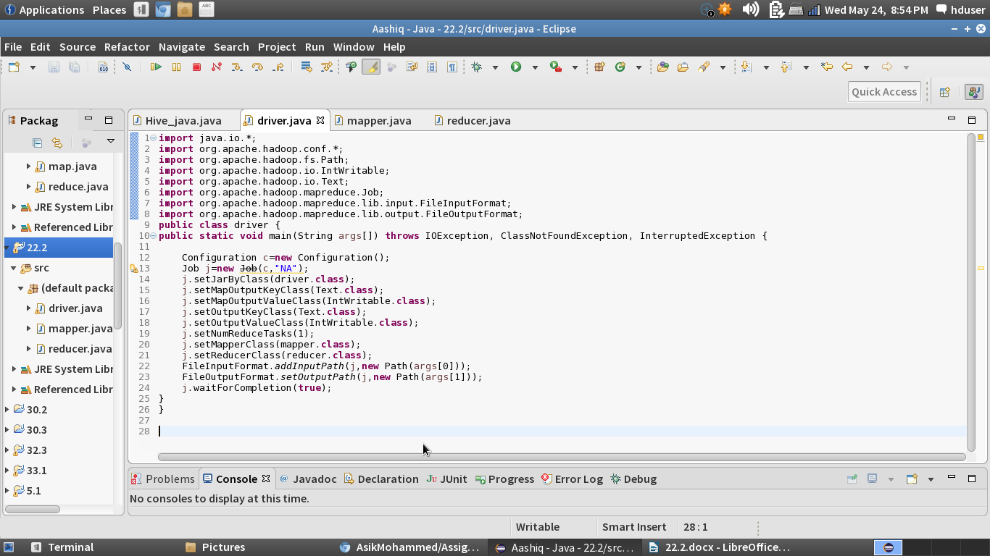

**Mapper Class:**

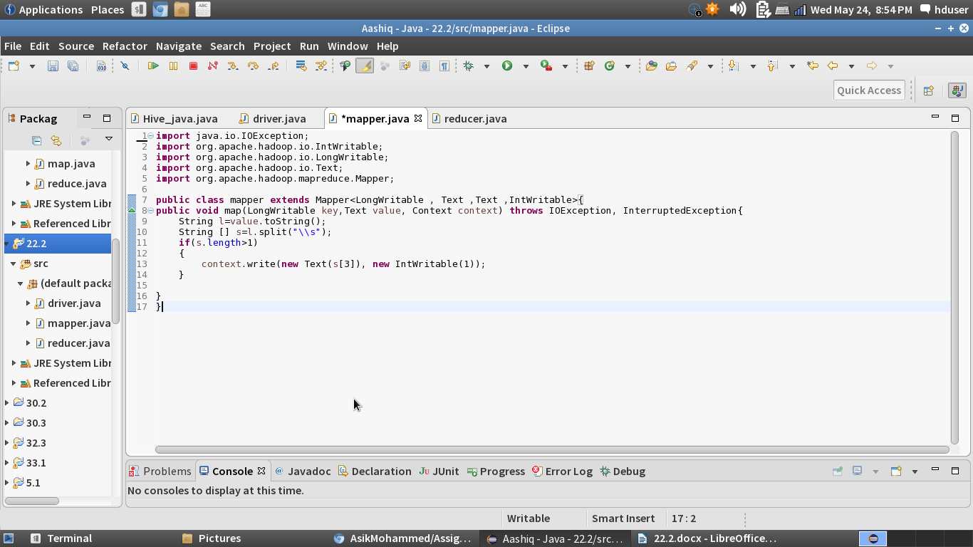

**Reducer Class:**

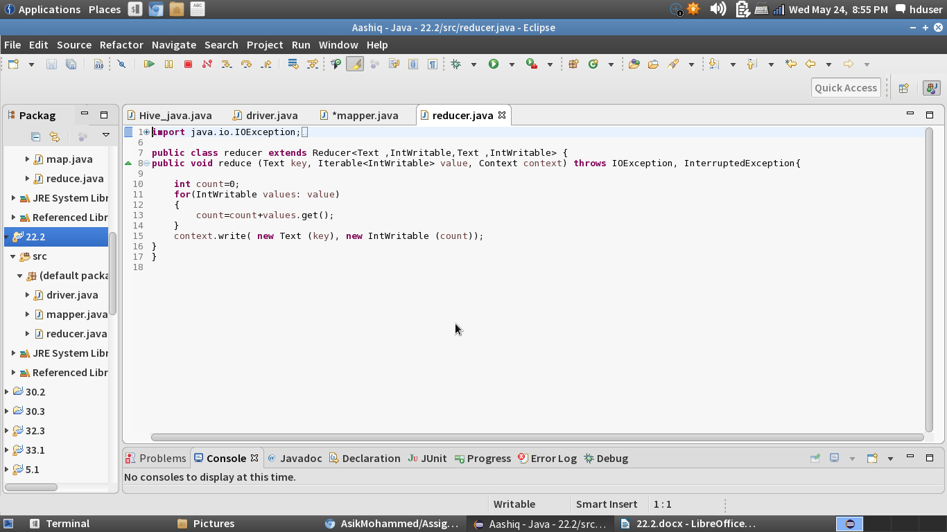

**Running the Jar File:**

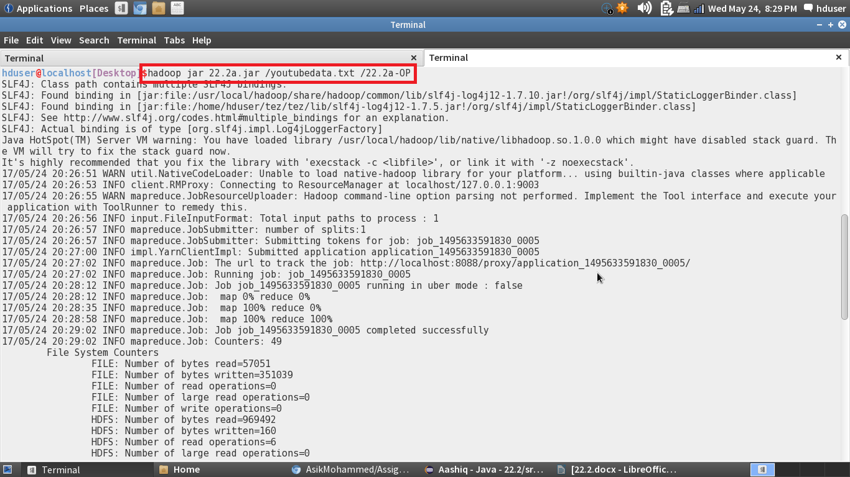

**Output:**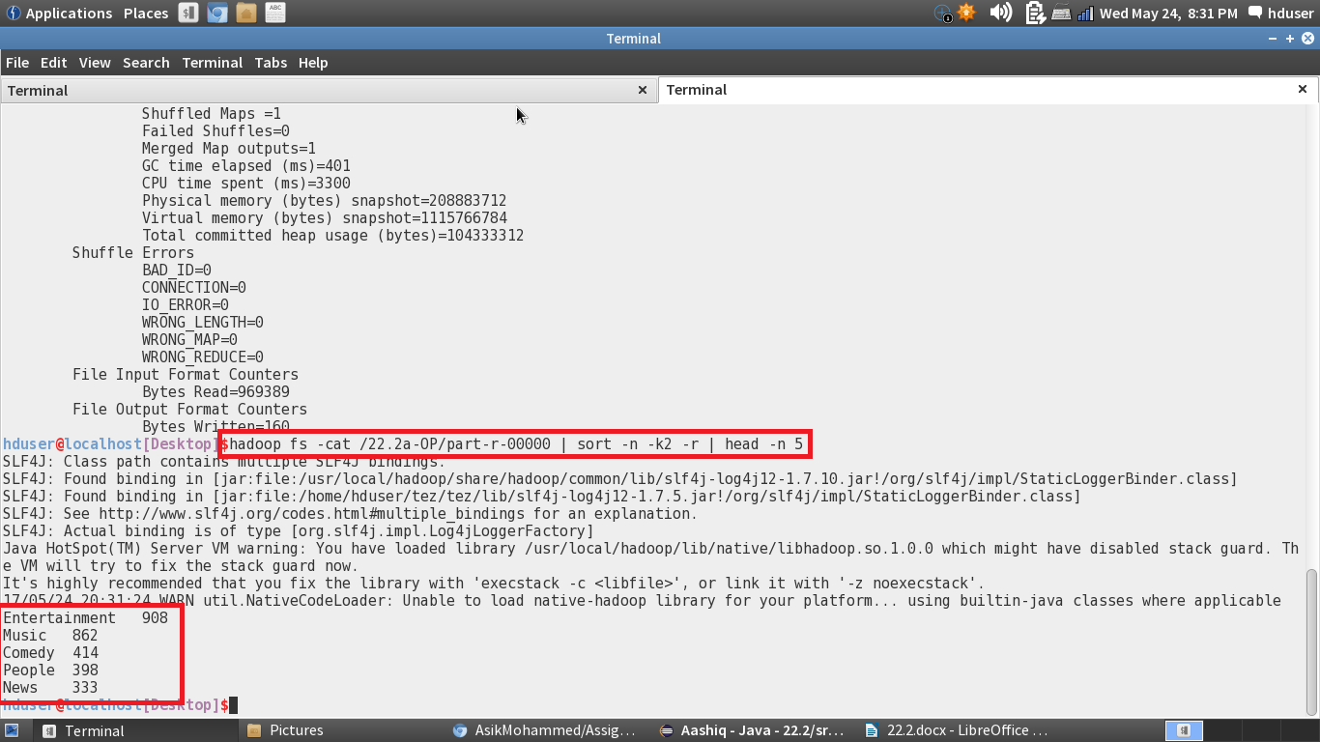

**Find the top 10 rated videos in youtube.**

**Driver Class:**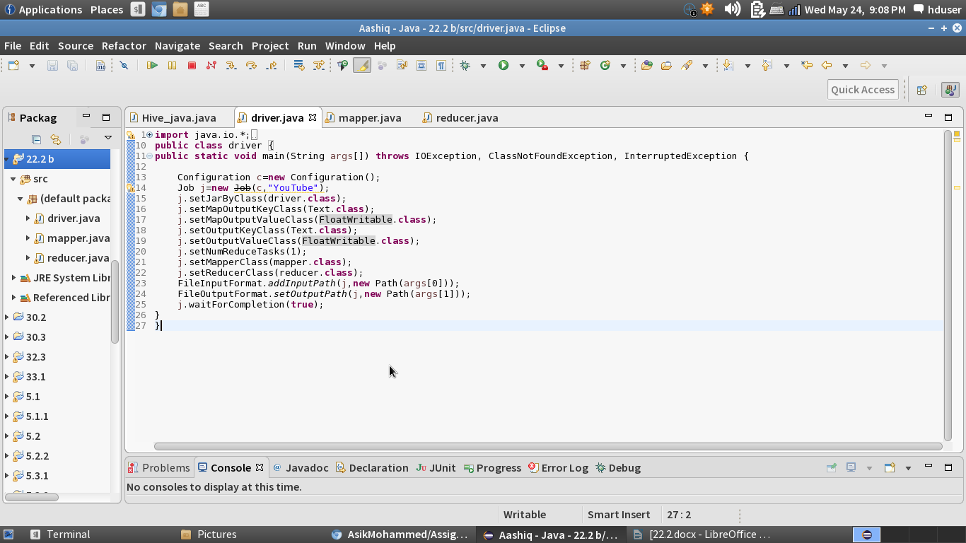

**Mapper Class:**

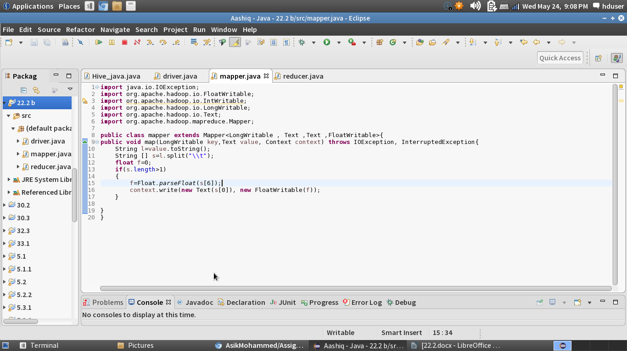

**Reducer Class:**

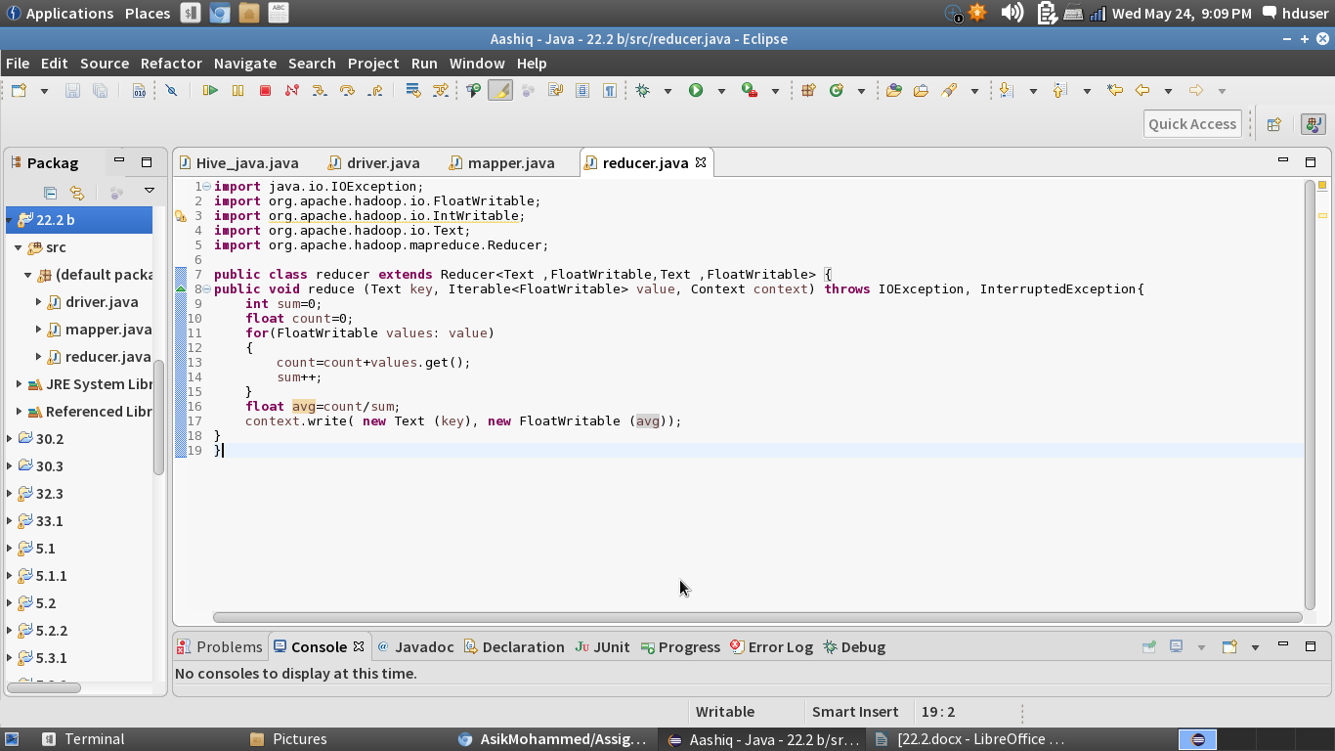

**Running the Jar File:**

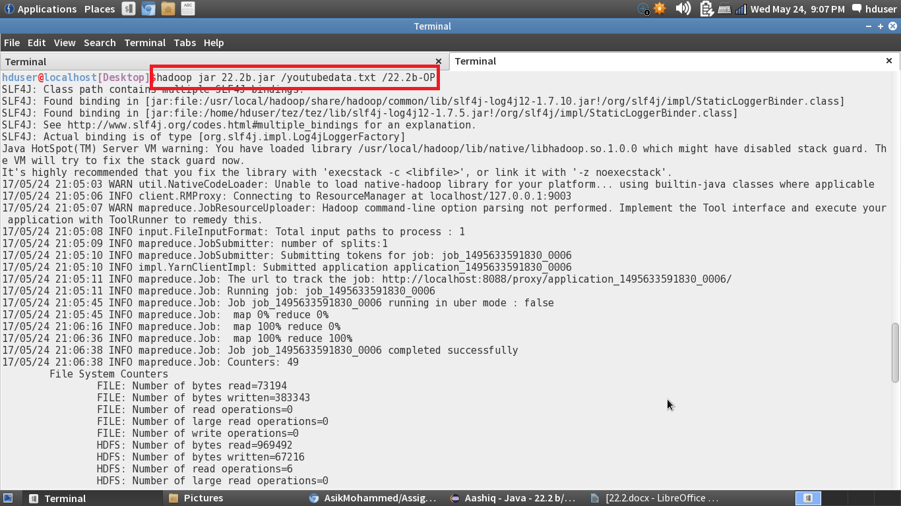

**Output:**

